微机原理与接口技术上机实验
实验十二
软件中断程序：
STACKS SEGMENT STACK
DW 128 DUP(?)
STACKS ENDS
DATA SEGMENT
ARRAY DB 12H,34H,56H
COUNT DB $-ARRAY
SUM DW 0
INTSEG DW 0
INTOFF DW 0
DATA ENDS
CODE SEGMENT
ASSUME CS:CODE,DS:DATA ,SS:STACKS
START: MOV AX,DATA
MOV DS,AX
MOV AX,STACKS
MOV SS,AX

MOV AH,35H
调用功能号为35的DOS调用，获取原中断向量，保存在存储器中，方便恢复
MOV AL,0BH
INT 21H
MOV INTSEG,ES
MOV INTOFF,BX
CLI
PUSH DS
调用功能号为25的DOS调用，设置新的中断向量0B
MOV AX,SEG SUM1
MOV DS,AX
MOV DX,OFFSET SUM1
MOV AH,25H
MOV AL,0BH
INT 21H
POP DS

INT 0BH 调用中断
MOV DX,INTSEG

恢复中断向量
MOV DS,DX
MOV DX,INTOFF
MOV AH,25H
MOV AL,0BH
INT 21H

MOV AH,4CH
INT 21H
SUM1 PROC NEAR 子程序，执行存储器中三个数相加
MOV CL,[COUNT]
CMP [COUNT],0
JZ EXIT
MOV AX,0
MOV SI,0
AGAIN: ADD AL,[ARRAY+SI]
ADC AH,0
INC SI
LOOP AGAIN
MOV SUM,AX
EXIT: IRET
SUM1 ENDP
CODE ENDS
END START
程序调试结果：
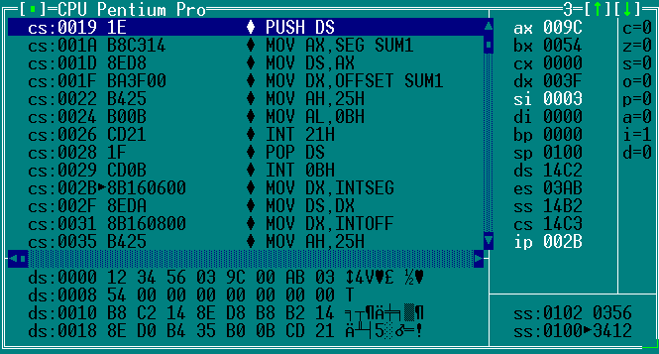
计算器运行结果：
12H+34H+56H=9CH

